Birla Institute of Technology & Science, Pilani
Work Integrated Learning Programmes Division
Second Semester 2019-2020

Mid-Semester Test
(EC-2 Regular)

Course No. : SSZG526
Course Title : Distributed Computing
Nature of Exam : Closed Book
Weightage : 30%
No. of Pages = 2

No. of Questions = 6
Duration : 2 Hours
Date of Exam : Saturday, 07/03/2020 (AN)
Note to Students:
- Please follow all the Instructions to Candidates given on the cover page of the answer book.
- All parts of a question should be answered consecutively. Each answer should start from a fresh page.
- Assumptions made if any, should be stated clearly at the beginning of your answer.

- What is a parallel system? [1]
- What are the classifications of Parallel Systems? [4]
- What factors influence choice of design of parallel systems? [2]
  - How is emulation of message passing on a shared memory system accomplished? [3]

  - What is a distributed program? [1]
  - Explain Lamport’s “happens before” relation with an illustration. [3]
- What is Vector time? [2]
- How will the following set of processes execute in vector time? [4]

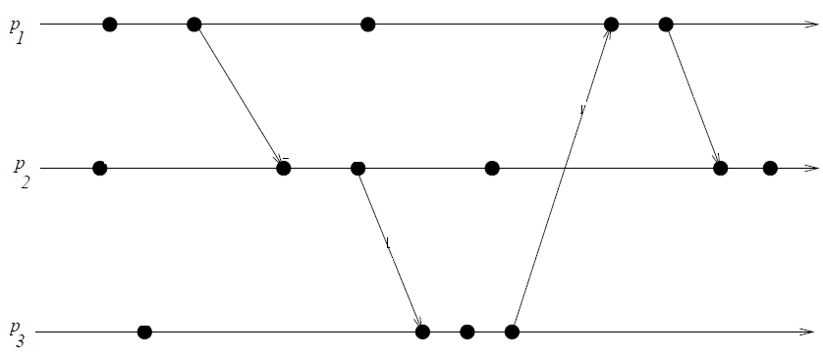

- What is a Cut? [1]
- Identify the cuts in the following space time diagram of the four processes. [1]
- What is do you find consistent and/or in consistent in the diagram and why? [2]
SS ZG526 (EC-2 Regular) Second Semester 2019-2020 Page 2

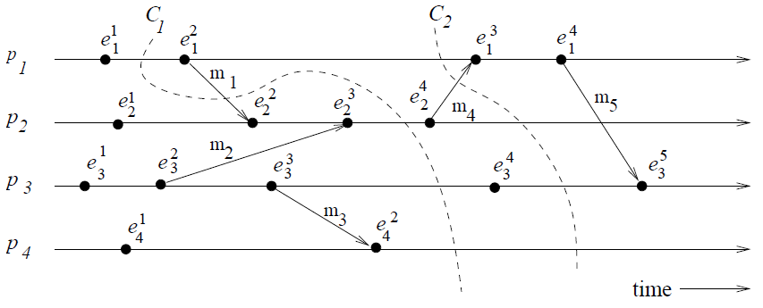

- What do you understand by Casual ordering? [2]
- Explain the Birman-Schiper-Stephenson Protocol with an illustration/example of your choice. [4]

***********

